Name _______________________________
For each of the following find:
- Vertical Asymptotes
- Horizontal Asymptotes
- Oblique Asymptote
- zeros
- y-intercept
- holes
Then sketch the graph. Check your answer with your calculator or computer.
1)
2)
Key
1)
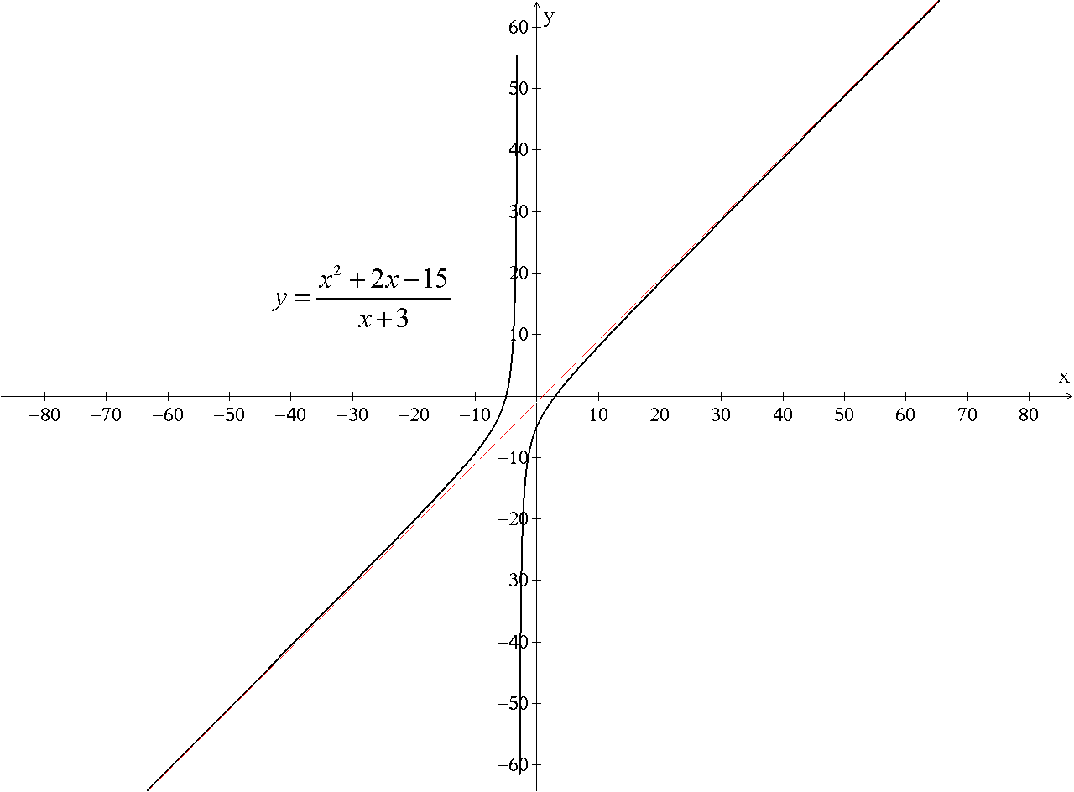
a)
b) none
c)
d) -5, 3
e) -5
f) none
2)
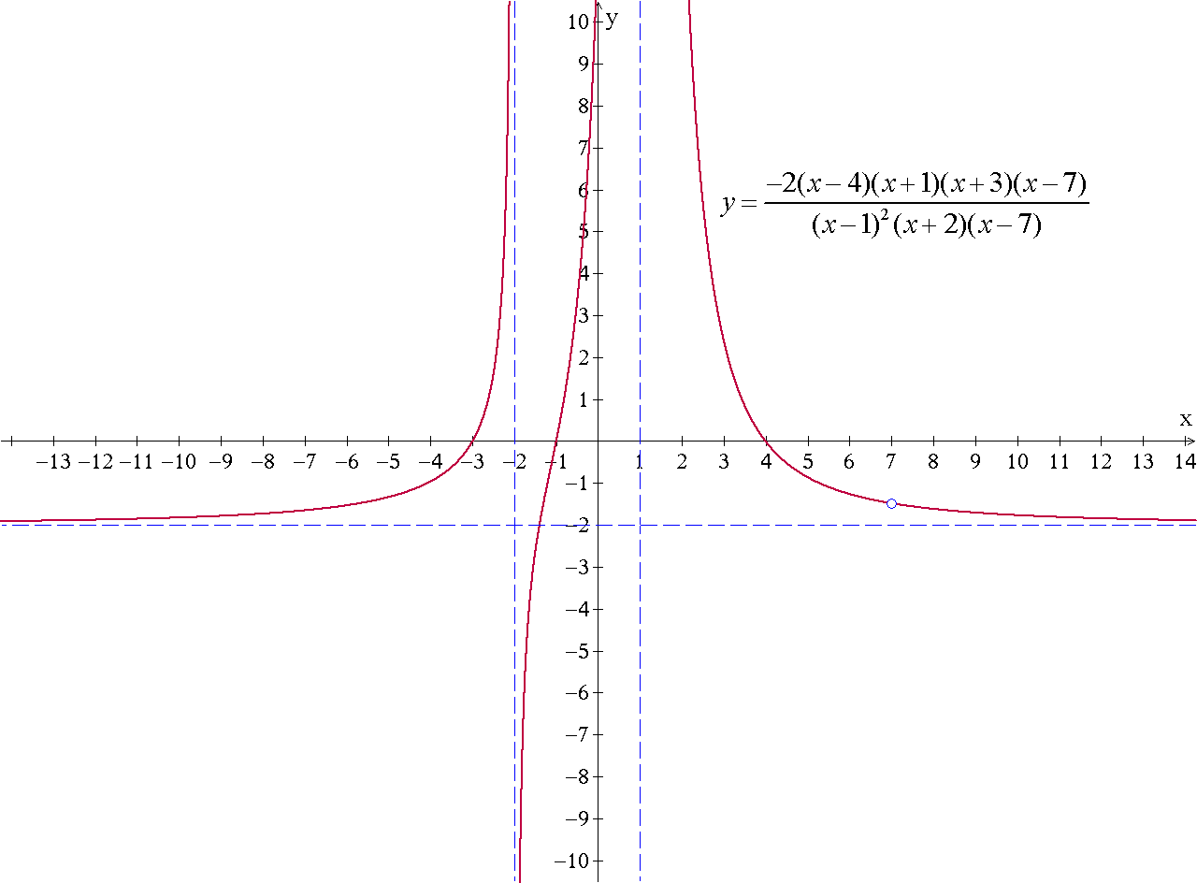
a)
b)
c) none
d) -3, -1, 4
e) 12
f)

